Control Engineering

Handout – Online Laboratory 4

Name: *Colda Andreea Ariana*

Group: *30332*

For the process described by , with ,  and the performance indicators set



design the simplest controller possible using the dipole correction method. Demonstrate by plots that the imposed performance indicator set is met.

*2.8867 (s+0.2) (s+0.03547)*

*Hr = -------------------------- before the simplifications*

*(s+1.351) (s+0.01895)*

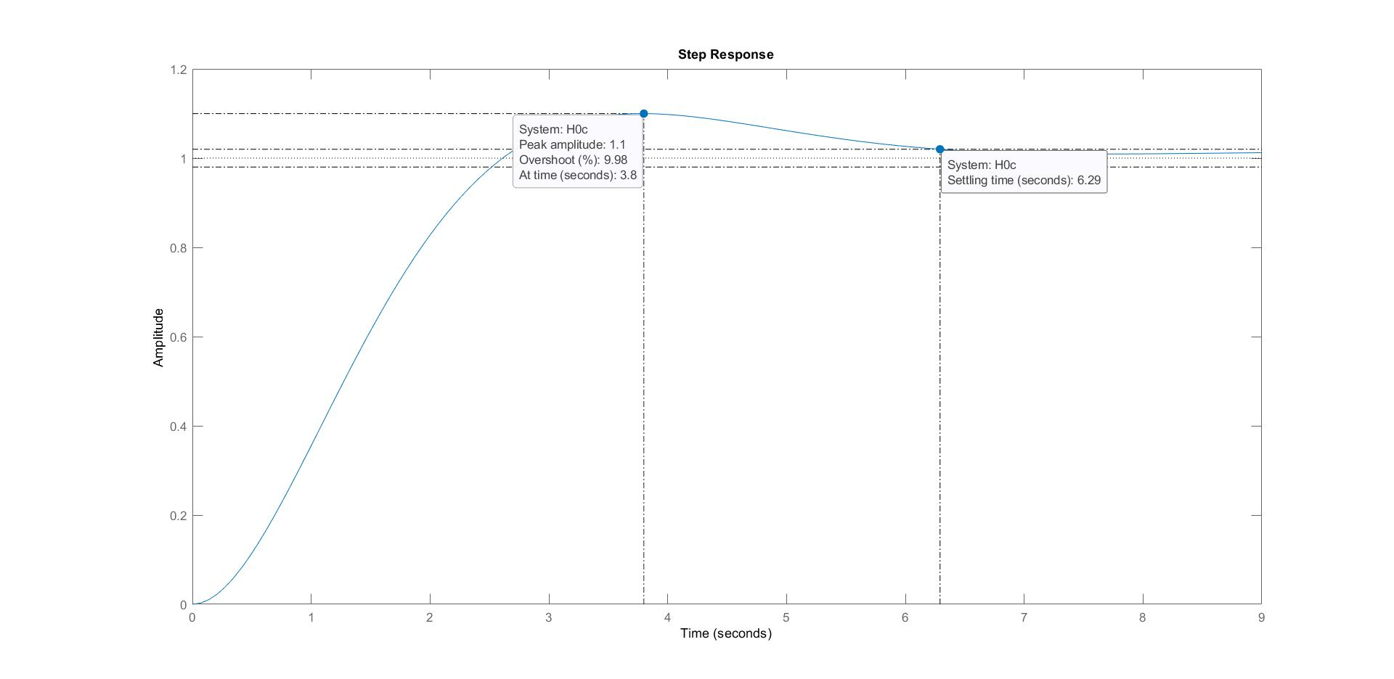

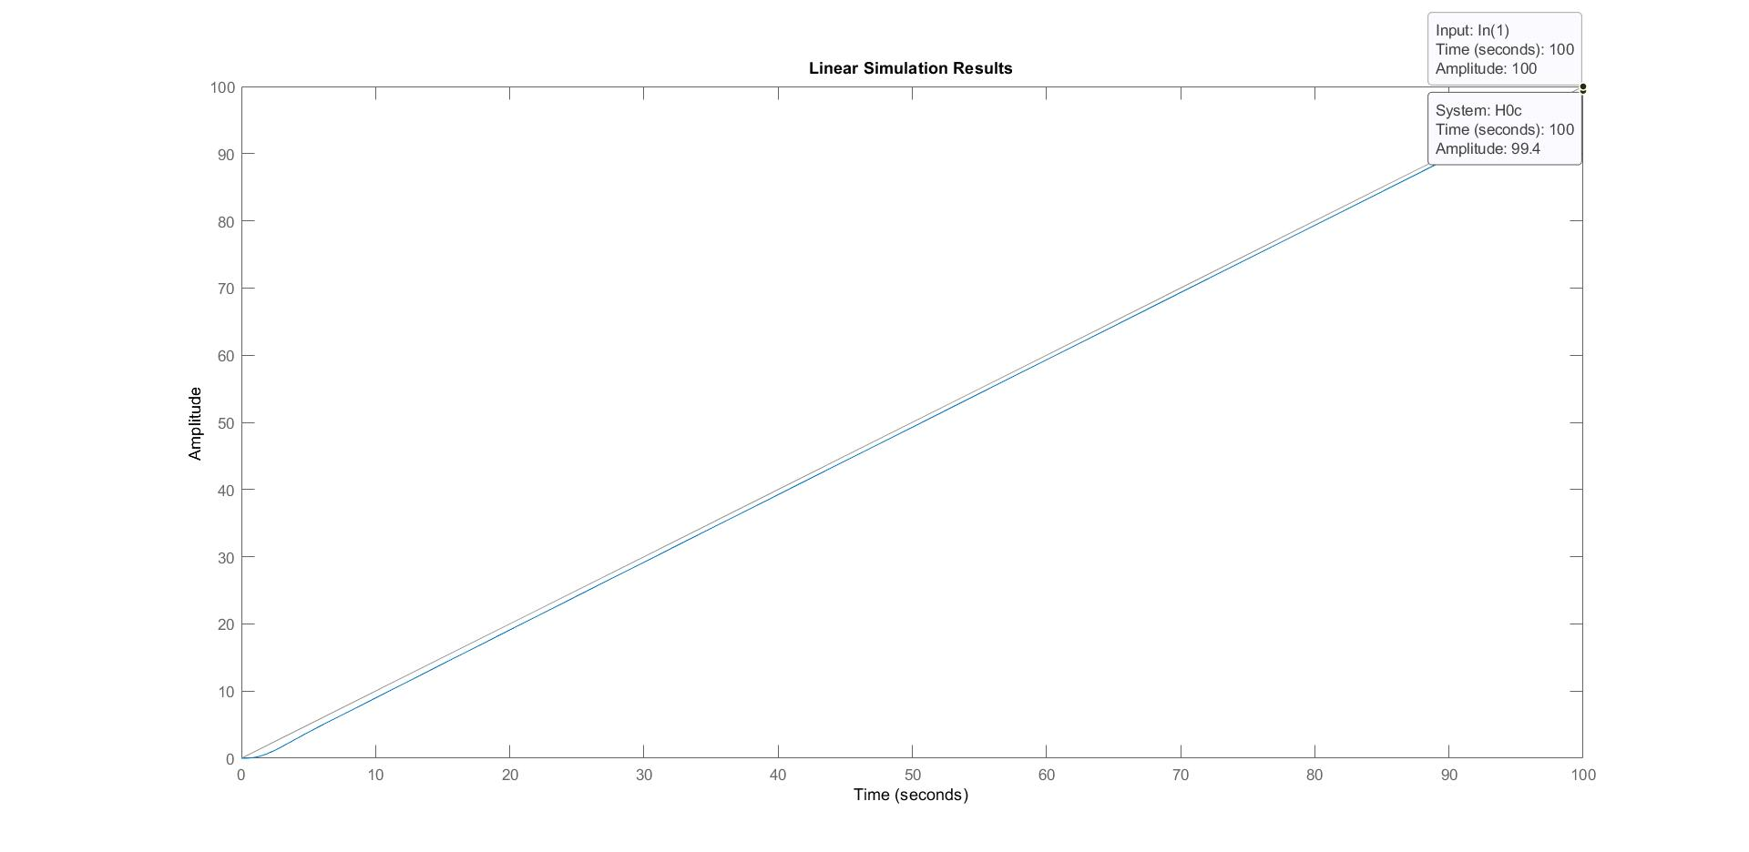

*After the simplifications the performances can not be met anymore.*

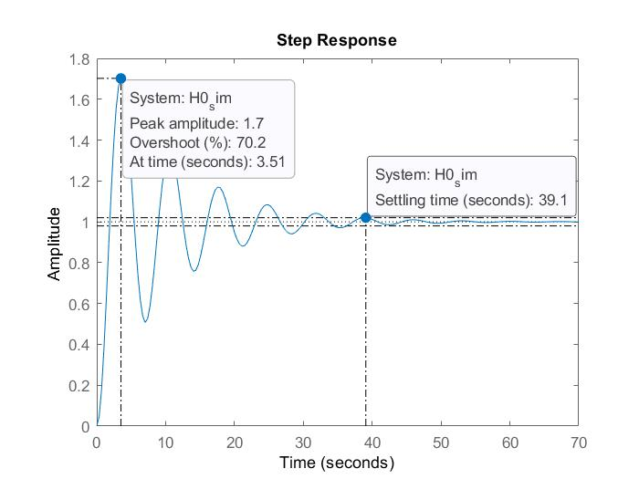

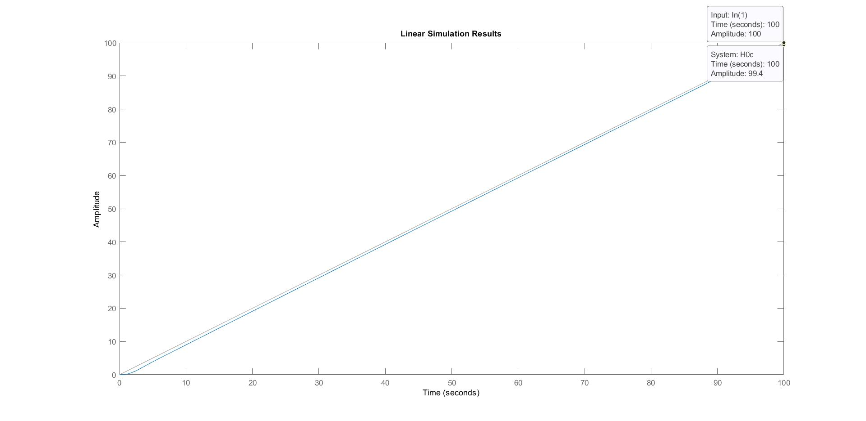

What is happening when the process parameters (Kf and Tf) are changing?





*Add plot here.*

*Briefly comment the obtained performance.*